Programming for the user Assignment 2

# Deliverable 1:

## Provide a list of functional and non-functional requirements

### Functional Requirements:

* Application must be created so that it can be used on the web.
* The website must be written in HTML, CSS, JavaScript and PHP
* A database must be used in order to store appointments that have been booked
* The students must be able to book an appointment with one of the support services, once booked that appointment will then become filled in so no other user can book one at that time.
* The website must provide information about the different services that are available to the students allowing them to gain more information about the services than they already know.

### Non-Functional Requirements:

* The website must be able to accommodate to all users with and without disabilities therefore allowing anyone to use the system.
* Any user information must be stored securely so that it can not be gained by an unwanted person (hacker)

You can use the example overleaf to create a typical user persona that may be a candidate for the new system you are developing.

### Persona description and pain points

Melanie is a current student at Discovery University Dundee and is currently studying Phycology and counselling. She commutes to university every day by using the bus which takes around half an hour, during this time she likes to use her iPhone to get tasks done such as paying bills, making calls and arranging her schedule for the day.

Melanie has got a visual impairment and is required to use a larger text when on computers and uses a magnifying glass to read otherwise uses audio books. She often uses the app “Audible” to listen to her audio books as she prefers the audio instead of reading larger text.

Melanie is always on the move with balancing her social life, education and her job as a full time waitress. Due to this she is always looking for something fast and easy to use so that she can keep her free time as free as possible. She likes to watch movies and series’ on Netflix in her free time, she uses her phone and laptop to do these as these are 2 devices she can take anywhere she goes.

Melanie is currently going through a tough part in her life resulting in her feeling down and having a loss of money which is also having a negative effect on her education at the university. She has looked at different websites for support however feels like she needs a face to face conversation with someone that has knowledge in how to deal with her current situation.

**More about Melanie**

**Motivators for the Website:** Melanie is wanting a face to face conversation with someone to help her and has heard that the university offers support with her situation. She has conducted research into finding out about the services that the university offer however has wasted hours of her valuable free time with a result with nothing back. She is wanting a site that will be quick and easy to get around and will provide enough information about each service so that she can quickly book an appointment with someone in the service she wants to gain help from.

**Product Trigger Point:** Melanie had heard about universities offering support for her situation and wanted to find out if her university offered the same types of support. She then asked around her friend group who knew that the university offered the services she wanted however, they never knew where to look or how to get in touch with these services.

**Personal Computer:** Melanie does not have a Desktop PC but has a Laptop and iPhone that is more than capable of preforming any tasks she wants on any applications.

**Internet Usage:** When ever Melanie has got free time, she will be on her devices checking out social media, YouTube and listening to books on Audible.

**Mobile:** Melanie is currently using an iPhone 7 but is wanting to by the Samsung 9 for her next phone, she commonly uses this to communicate on social media and texting and when there is no room for a laptop.

**Social networking:** Facebook, Instagram and Twitter are what she commonly uses to stay up to date with the current news and her friends.

**YouTube Channels:** David Dobrik, Dude Perfect, T-Series is her common YouTube channels to watch in her free time.

**Magazines/ Books:**  Currently reading through the Harry Potter Book Series at night time and when she fancies a change from her electronic devices.

### Narrative (scenario of the use for the new system)

The new system will be built for and around the students and be accessible anywhere on any device connected to the internet. If we use Melanie as an example of a student that will be using the site/ system then we can address how the website will accommodate her needs and situation.

Melanie talked before about how she arranges her schedule for the day on the bus to university on her iPhone this means that the website must adjust its layout depending on what device it is being viewed on. This will allow for the site to be easier to use as the layout will be better for the phone than if it was viewed on a laptop. This will make it, so no matter device is being using to view the site it will always look clean and therefor resulting in an easier and quicker experience.

She also has got a visual impairment which has limited her capability of reading small text such as on a book. The system that will be developed will have the ability to read out information through using audio or the ability to enlarge the text on the screen making it easier to read. This will also tackle any deaf or blind users as they will both be able to use at least one of these options.

Melanie has also talked about not knowing which service will be best for her meaning that she will need a description of each service allowing her to make her choice easier. The site will have a text box with a few sentences that will allow the user to read a brief overview of the service, after reading that they can click a drop-down button that will show more information such as “book appointment” button and a contact number.

The site will have a simply layout and design to it making it easier to navigate through and see information that could possibly be missed if the design was too advanced and diverted the user’s attention to something else. Each page on the website will have similar layout and consistency so that the user will not have to learn/ get use to each different page layout, but instead can do the activity that they loaded the site for.

# Deliverable 2:

## A set of prototype screens for the complete app.

###### **Default page layout and design for each page on the site to maintain consistency**

Header/ banner with logo and page name

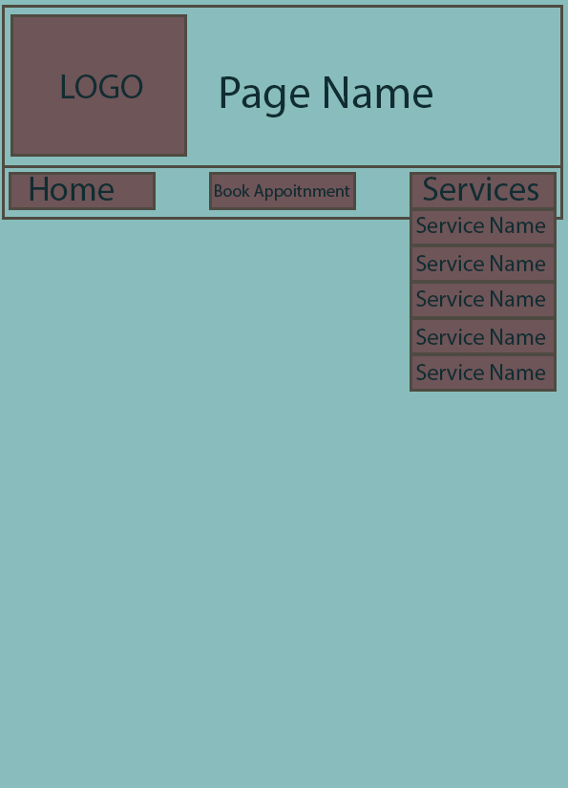

What the drop down menu will look like

Navigation bar with “Home” button; “Book appointment” button and a “Services” drop down button

###### **Home page layout with elements**

Using default page layout and design

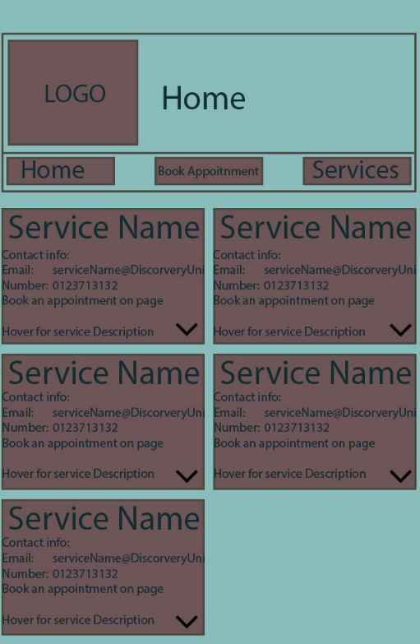

Shows current appointments booked

Current Appointments

Home page will have text boxes containing a header for the support service name, then it will have contact information, if the user hovers over the text box a larger text box with a description will appear (can be seen in next photo)

###### **Home page with example of item being hovered over and description being shown**

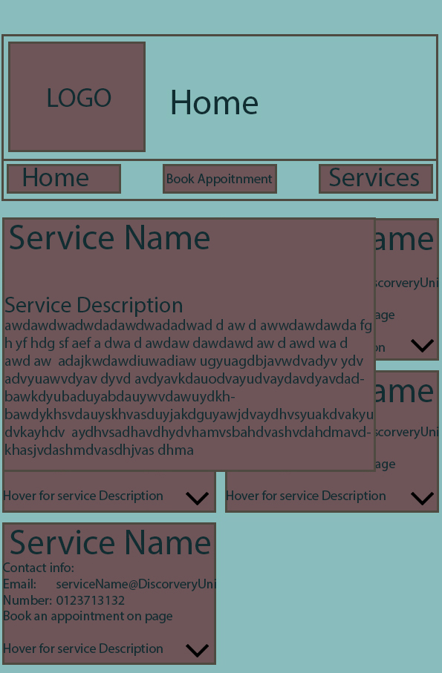

This is an example of what happens/ appears when one of the small service name boxes is hovered over. It will show some information about the service

###### 

###### **Book Appointment page**

Once all the fields have been selected the user can then book the appointment

The user will select a time on the date that they want after selecting the service in step one, all un available times (one that have already been booked will not show up.

These are dates of appointments that users can select from (users can only book appointments 7 days before)

This part is where you select what service you want to book an appointment for, this is the first step

Book Appointment Page will have the same design and layout at the top like all other pages

###### **Services example page:**

###### 

Each page will be for a certain support service, each page will have information about the service, the team of staff that work in the service, a booking link to the booking page and a list of contact information.

## A statement of the 3 tasks selected for evaluation (and why they were selected).

### Task 1: Try and book an appointment for any service

This first task will require the testers to try and book an appointment for any service. I would watch the users to see where their eyes and mouse where on the screen to see where they would expect to find the booking page and if they click on anything that they think should take them to the booking form. I would also see if that the page layout and the system is easy to follow and understand and see if they would change anything or didn’t see something they should have. This will allow me to make the site more user friendly as a layout that I think will be good might not be the best for everyone else.

### Task 2: Find information about any of the services

This task will be used to see where the users would expect to find information on certain services as they might expect certain areas to contain the information or even just a brief overview of the service with not much detail. I will use this information to then change the layout or even certain amounts of text in different places. This will then allow for the site to be easier to use and take less time to learn, as I can change the site to match the preference of the users. I will also ask the testers if there is any extra information they would like on the site.

### Task 3: View your current appointments.

This final task will require the testers to find an already book appointment (appointment will already be book on the account without them knowing what time or what service). Here I will see where they first look at on the screen/ website as they might all expect it to be in a common place. After they have found the booked appointments I would then ask them what a better idea for the location of would be the “booked appointments bit”.

## A report on the outcome of the evaluation with 3 testers. You can consider how long it took users to do some tasks, or whether they could do a task.

Each of the 3 testers were given the same 3 tasks to complete so I could compare the results. On the first test the users found it easy and simple enough for them to book an appointment and felt like it was self-explanatory enough. The all liked that on the “Services” pages it included a link at the bottom of the page to the book appointment as they found that more useful than going to the top of the page to click on “book an appointment”. All 3 testers felt the same and it took them very little amount of time to book an appointment. However, 1 of the testers did believe that it an extra label on each step could help the user to understand what they need to do first then 2nd then 3rd. The tester suggested a simple number label or a label above each step saying “Step 1” or “Step 2” etc.

The next test was to see if the testers could find information about any of the services that they picked, the testers did find the page for the services that they wanted to find however it did take longer than it should have. The testers said that the drop-down services button was not clear it was a drop down so a simple arrow symbol could help with this problem. One tester also said that they tried to click on the service on the home screen expecting it to take them to the services’ page however it didn’t. This will be easily fix with a simple link.

The final test that the testers were required to conduct was to find out what appointments they already had booked. All 3 of the testers instantly found the location of which showed the currently booked appointments. However, all 3 of the testers said that they did not like the location of the “currently booked appointments”. After talking to the testers, the all came up with 3 different ways that the currently booked appointments could have been displayed. The first option was to have a simple bar at the top of all the pages that showed all the currently booked appointments on a slide show in order of appointments that were due sooner being displayed first. A 2nd option was to have a bar on the side of the home page that showed all the currently booked appointments. The final tester suggested a whole new page with all the currently booked appointments that can be accessed from the nav bar.

## Use the System Usability Survey and report the scores, providing a brief interpretation of the findings.

Testers SUS Sheets:

Tester 1 (SUS Score: 80) Tester 2 (SUS Score: 82.5)

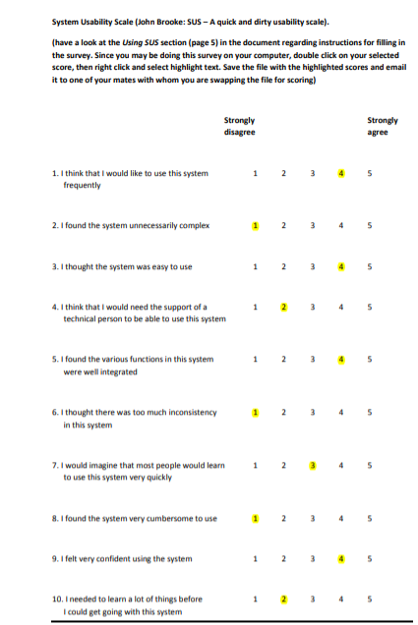 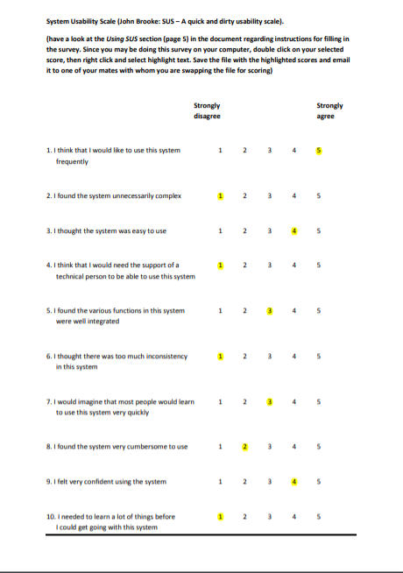

Tester 3 (SUS Score: 85)

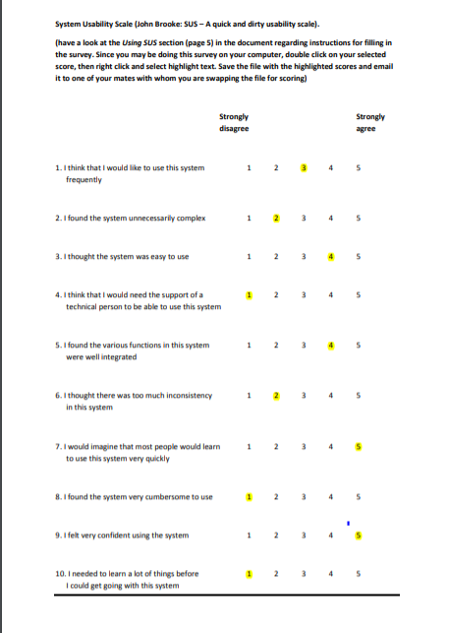

Viewing the SUS scores of the 3 testers score sheets it is clear that my prototypes has gained positive feed back as it averaged a 82.5 SUS score from the 3 testers. The score of 82.5 as an average puts it just below 85 which is classed as the lowest number to fall under the “Excellent” Grading therefore meaning that the site graded a “Good” score. This means that I would possibly look at a few other things to change such as the location of the “My Booked Appointments” which would increase the ease of use/ learnability scores.